Software Requirements Specification

The document in this file describes the design and functionality of feastfreedom.com website. The server will utilize Django web development framework with RDS MySQL database and run on AWS cloud platform. It is designed to be scalable and reliable.

Project members:

Xiaochen Li

Sean Rakhimov

Rahita Jose Kanjikal

Platform details:

AWS Linux 2

RDS MySQL

Apache2

Python 3.6

Django 2.1.7

Contents:

1. UML page 2
2. Mock ups page 3
3. Flow page 4
4. Use case diagram

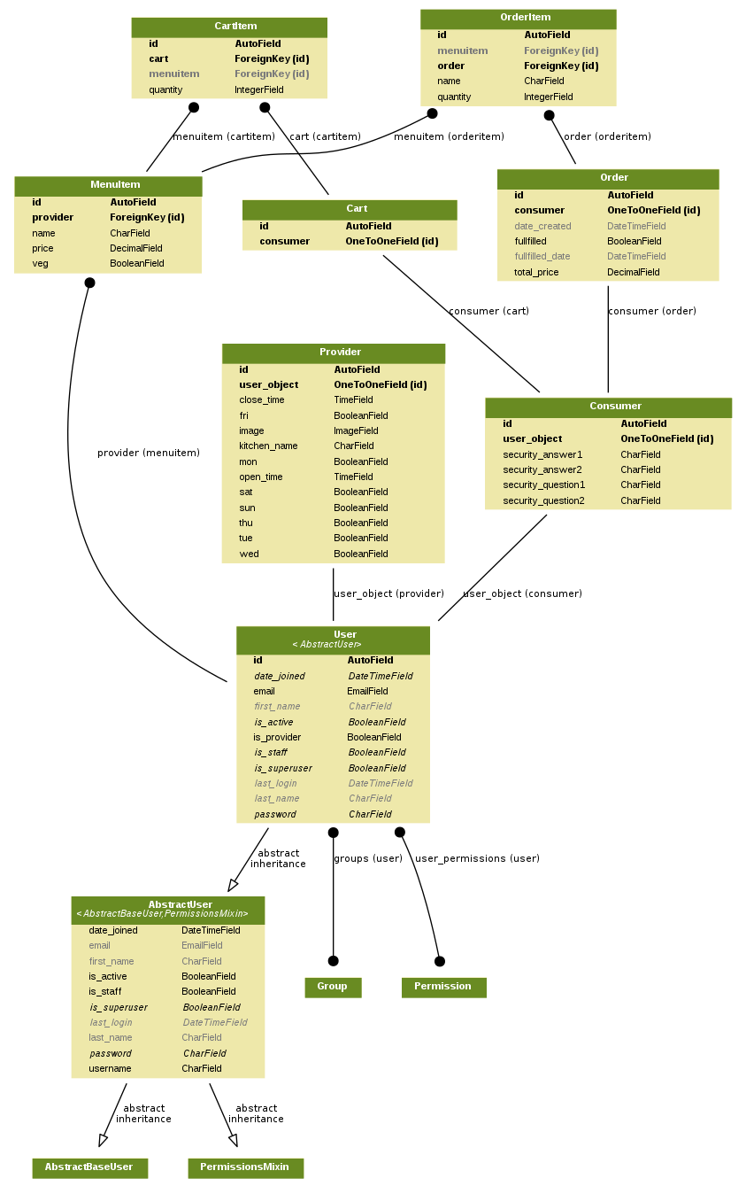

UML and data structures

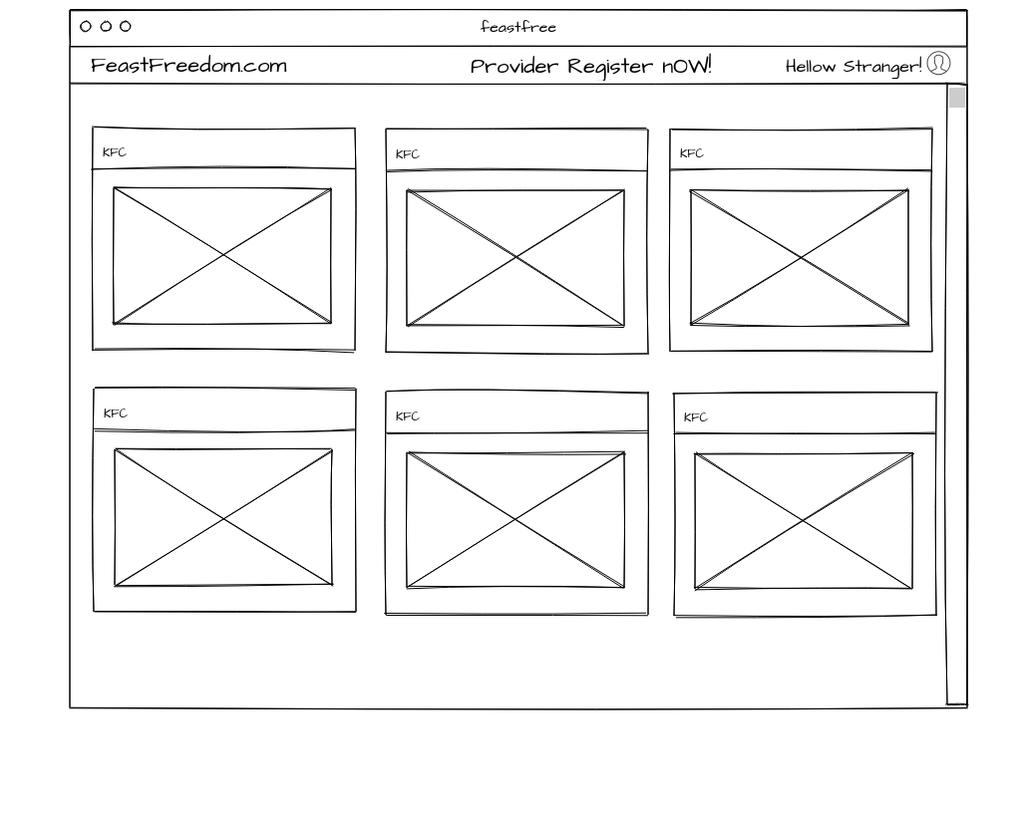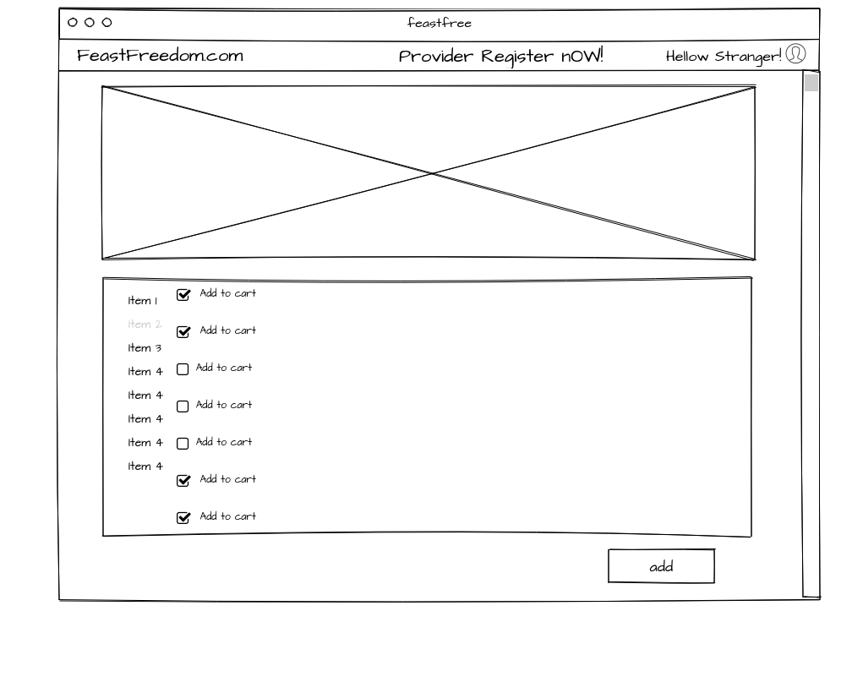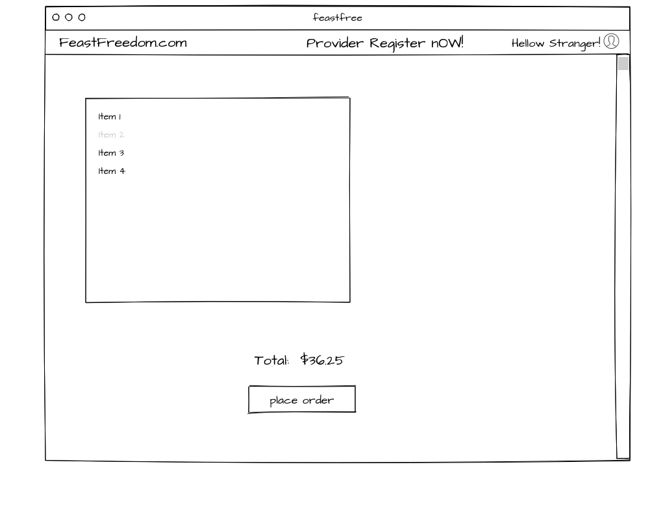

Mock ups

Use Case Diagram

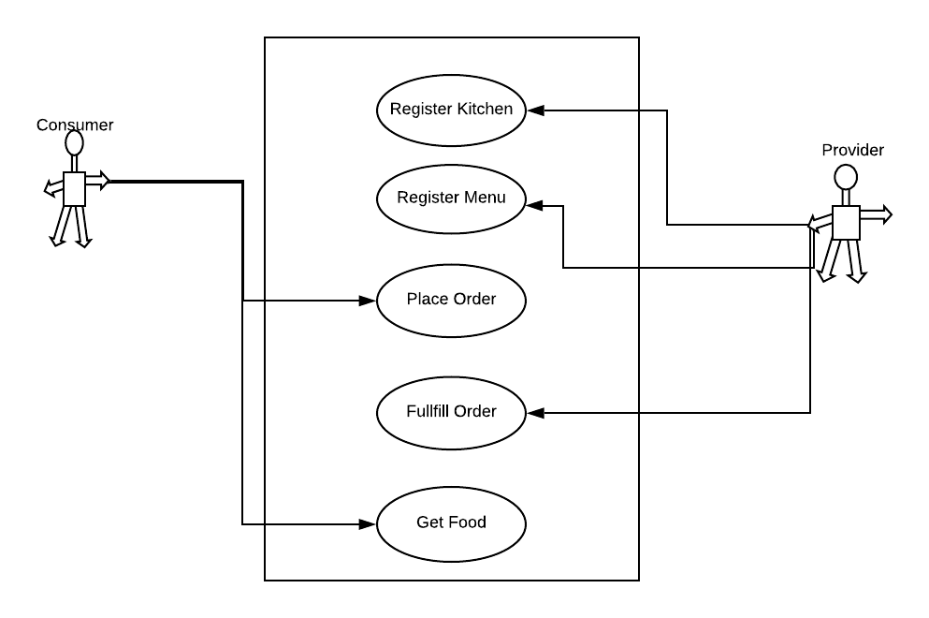

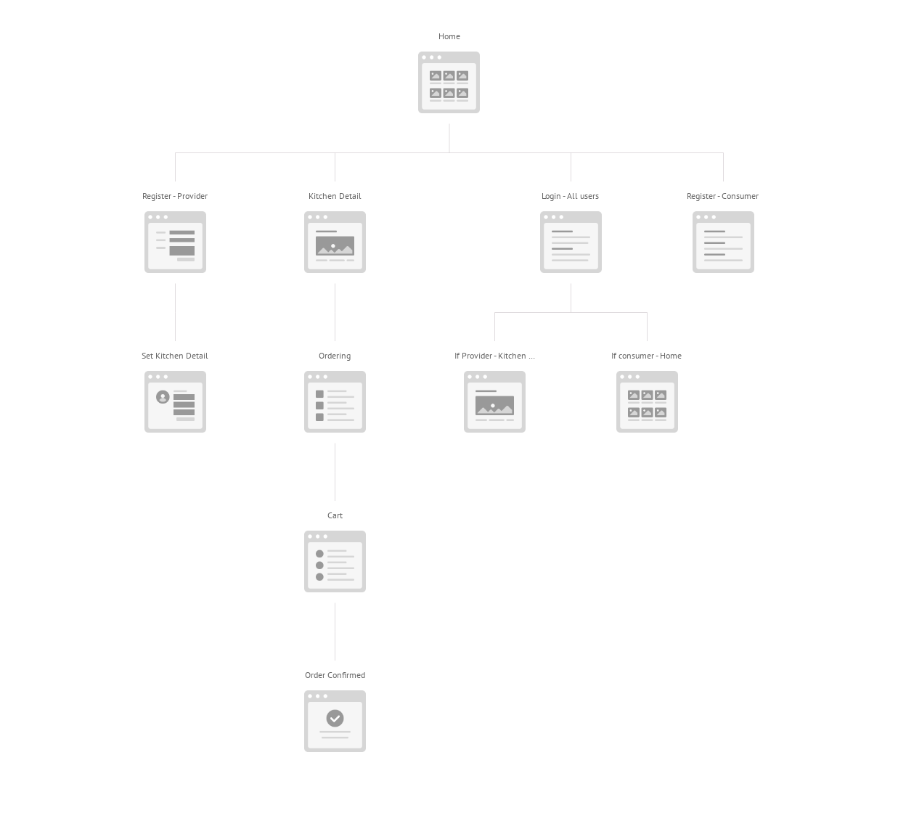

Website Flow